- The Monetary Policy Committee's decision to keep Bank Rate at 4.5% was no surprise. We expect the committee to continue cutting at alternate meetings until at least August, when it will start to digest evidence of the impact of the increase in employers' national insurance contributions. So far, the impact of the upcoming tax change on redundancies and vacancies appears to be small.
- The announcement of £5bn of welfare cuts offered a strong hint that the government is having to cut spending to remain compliant with its fiscal rules. We expect any further spending cuts to be focused on the outer years of the Office for Budget Responsibility's forecast horizon. This will be a temporary fudge that buys time to work out how to create room to ramp up defence spending.
Since it began loosening policy in August, the Bank of England's Monetary Policy Committee has settled into a cut-hold tempo. This had meant a majority to hold policy was virtually certain at this week's meeting and so it proved, with an 8-1 vote to keep Bank Rate at 4.5%.
The minutes were non-committal on where policy is likely to go from here, reflecting the MPC's uncertainty over the growth and inflation outlooks and varying views on whether weak demand or weak supply is the dominant factor. The minutes of March's meeting gave advanced warning that the MPC will recast its inflation scenarios in May to try to better address this question.
The MPC's guidance on how it will monitor the balance between supply and demand has been fuzzy, but the strength of pay growth is likely to be a key influence. As things stand, pay appears to be evolving broadly in line with the BoE's expectations. Headline (three-month average of the annual rate) private sector regular pay growth was 6.1% in January, a touch below the BoE staff's projection for Q1 as a whole, and there was some evidence that the strong momentum of late-2024 was beginning to fade (Chart 1).
Chart 1: The upward momentum behind pay growth seems to have started to ebb
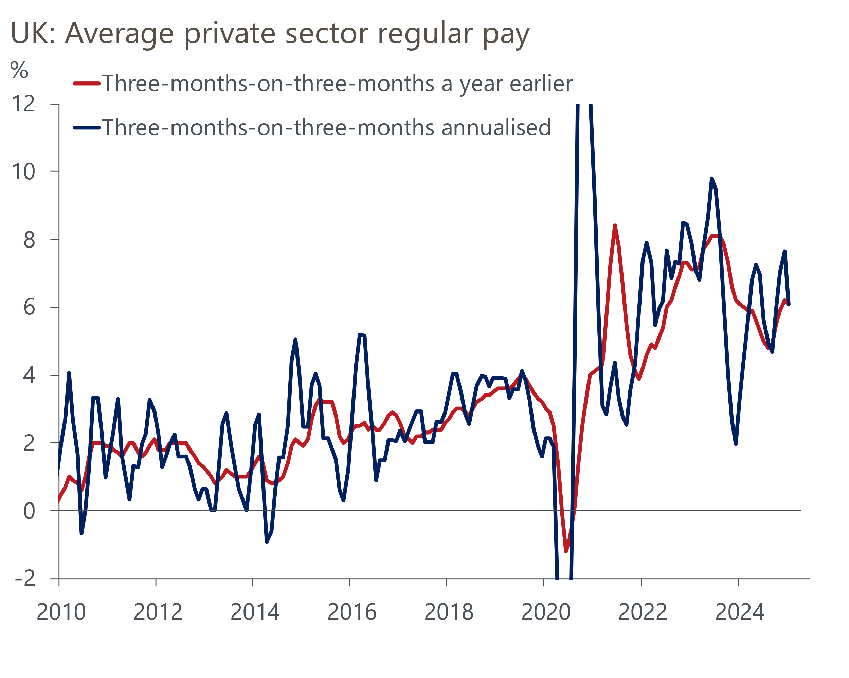
Source: Haver Analytics
The MPC expects pay growth to cool further in response to April's increase in employers' national insurance contributions. But hard and soft data continue to offer conflicting views on the impact of the increase in employment costs on the labour market.

Business survey data points to sizeable jobs losses and much softer pay trends than the official series. But the picture from official data is much firmer. After falling for more than two years, job vacancies have stabilised of late. HMRC's count of employees on payrolls edged up in January and February. Meanwhile, redundancies have remained relatively low and appear likely to remain limited – firms planning to dismiss 20 or more employees must submit HR1 forms to the Insolvency Service, but the number of employees covered by HR1 forms submitted recently has been in line with the 2024 average (Chart 2).
Chart 2: Redundancy levels and notifications remain at low levels
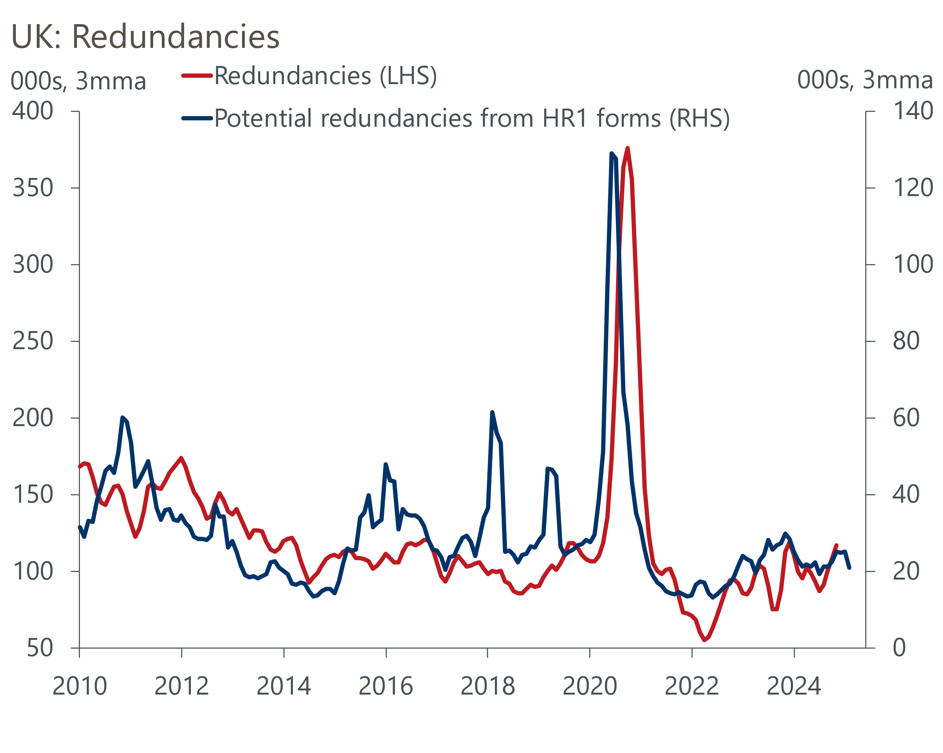
Source: Haver Analytics
Until the MPC has a better handle on how the NICs rise is playing out, we expect rate cuts at alternate meetings to remain the norm. The August meeting will be first time that the MPC has some hard data to work with, so that's likely to be the next meeting with genuine uncertainty around the policy decision.
Turning to fiscal policy, the announcement of welfare reforms offered a strong hint that the Office for Budget Responsibility's forecast update – which will be published on March 26 – has left the government needing to cut spending to remain compliant with the fiscal rules. The government expects the reforms to reduce welfare spending by more than £5bn in fiscal year 2029-2030, the focus year for the fiscal rules.
The bulk of the savings come via restricting people's ability to claim the Personal Independence Payment, which aims to compensate claimants for the additional costs of being disabled. Further savings will come from cutting the generosity of the health element of universal credit. Theoretically this should reduce the incentive to claim incapacity benefits and boost employment, albeit this only applies to those with health conditions that don’t prevent them from working. Arguably the incentives to work for those who don't receive health-related benefits will be weakened by the increase in the basic universal credit award.
If the OBR agrees that welfare reforms will cut government spending by £5bn, it will offset most of the increase in debt servicing costs caused by movements in financial market pricing since October's Budget. But there's several other moving parts that are much harder to predict. There are strong arguments for the OBR to revise up its forecast for wage growth and cut its assumptions for potential output, changes that would have opposing impacts on their borrowing projections. There's also the question of the degree to which this year's borrowing overshoot can be explained away by cyclical weakness.
If the OBR's pre-measures forecast shows the government missing its fiscal rules, then we expect the Chancellor will respond by cutting the departmental spending totals she announced in the Budget. We suspect she will repeat a tactic used by her predecessor, making the cuts in the outer years of the OBR's forecast horizon, beyond the period covered by the summer spending review. But in any case, next week's update is likely to be an exercise in can kicking. The new plans will likely involve increasing defence spending to 2.5% of GDP, a commitment that will look inadequate if NATO increases its spending target to 3% of GDP in the summer. So there remains a high probability that there will need to be a more comprehensive rethink of fiscal policy in this autumn's Budget.

The week ahead
There's a busy week in prospect, with the highlight being Wednesday's Spring Forecast update from the Office for Budget Responsibility. Given movements in financial market pricing since October's Budget, it's likely that the OBR's forecasts will show higher borrowing than before. Given the Chancellor has said this will not be a policymaking event, any remedial action is likely to be confined to the welfare cuts announced this week and adjustments to the departmental spending envelope that was set in the Budget.
Data wise, we expect the results of March's flash S&P Global survey to come in close to February's underwhelming outturns. But with the increase in employers' national insurance contributions coming closer into view and Trump-induced trade policy uncertainty rising, the risks are skewed towards worse outcomes.
CPI inflation rose to a 10-month high of 3% in January, as December's unusual seasonal movements in the volatile air fares category unwound and food prices rose. We expect base effects in the services category to cause inflation to dip to 2.9% in February. But this is likely to prove temporary respite, with the CPI rate set to move close to 4% by the autumn.
For a second successive year, a sharp increase in sales in food stores caused retail sales to surge in January. But the level of sales in food stores in January was well above recent norms, so we expect some payback in February. As a result, we estimate that total sales fell by 0.5% m/m.
Table 1: Week ahead calendar
Date | Events | Period | Measure | Unit | Previous | Forecast
Mar 24 | S&P Global manufacturing | Mar | PMI | % bal | 46.9 | 47.0
Mar 24 | S&P Global services | Mar | PMI | % bal | 51.0 | 51.0
Mar 24 | S&P Global composite | Mar | PMI | % bal | 50.5 | 50.5
Mar 26 | CPI inflation | Feb | m/m | % | -0.1 | 0.5
Mar 26 | CPI inflation | Feb | y/y | % | 3.0 | 2.9
Mar 26 | RPI inflation | Feb | m/m | % | -0.1 | 0.6
Mar 26 | RPI inflation | Feb | y/y | % | 3.6 | 3.4
Mar 26 | Land Registry house prices | Jan | y/y | % | 4.6 | 4.4
Mar 26 | OBR Spring Forecast
Mar 28 | GDP | Q4 | q/q | % | 0.1 | 0.1
Mar 28 | GDP | Q4 | y/y | % | 1.4 | 1.4
Mar 28 | Retail sales inc fuel | Feb | m/m | % | 1.7 | -0.5
Mar 28 | Retail sales inc fuel | Feb | y/y | % | 1.0 | 0.5
Source: Oxford Economics

Key forecasts
Table 2: UK forecast overview
(Annual percentage changes unless specified)
 | 2022 | 2023 | 2024 | 2025 | 2026 | 2027
GDP | 4.8 | 0.4 | 0.9 | 1.0 | 1.5 | 1.7
Private consumption | 7.3 | 0.4 | 0.7 | 1.2 | 1.4 | 1.4
Fixed investment | 5.1 | 0.3 | 1.3 | 0.1 | 3.1 | 2.4
Government consumption | 0.6 | 1.0 | 2.0 | 2.4 | 1.6 | 1.6
Exports of goods and services | 12.6 | -3.2 | -2.2 | -1.6 | 0.9 | 1.3
Imports of goods and services | 13.0 | -4.5 | 1.6 | 0.0 | 1.5 | 1.2
Industrial Production | -6.4 | -0.9 | -1.7 | -0.8 | 0.8 | 1.0
Consumer prices | 9.1 | 7.3 | 2.5 | 3.2 | 2.6 | 2.2
Unemployment rate (%) | 3.8 | 4.1 | 4.3 | 4.5 | 4.5 | 4.3
Current a/c balance (% of GDP) | -2.2 | -2.2 | -2.8 | -2.9 | -2.9 | -2.7
Government balance (% of GDP) | 4.1 | 5.2 | 5.0 | 3.7 | 3.1 | 2.4
Central bank policy rate (%, EOP) | 3.50 | 5.25 | 4.75 | 3.75 | 3.00 | 2.50
10yr govt. bond yield (%, EOP) | 3.67 | 3.54 | 4.57 | 4.54 | 3.93 | 3.44
Exchange rate (US$ per £, EOP) | 1.20 | 1.27 | 1.25 | 1.25 | 1.25 | 1.26
Exchange rate (euro per £, EOP) | 1.13 | 1.15 | 1.21 | 1.21 | 1.21 | 1.21
Source: Oxford Economics
Table 3: Quarterly forecasts for the UK
 | 2024 |  |  |  | 2025
 | Q1 | Q2 | Q3 | Q4 | Q1 | Q2 | Q3 | Q4
GDP (% year) | 0.5 | 0.9 | 1.0 | 1.4 | 0.8 | 0.7 | 1.0 | 1.3
CPI inflation (% year) | 3.5 | 2.1 | 2.1 | 2.5 | 2.8 | 3.2 | 3.5 | 3.2
Bank Rate (%, EOP) | 5.25 | 5.25 | 5.00 | 4.75 | 4.50 | 4.25 | 4.00 | 3.75
10yr gilt yield (%, EOP) | 3.95 | 4.17 | 4.00 | 4.57 | 4.70 | 4.67 | 4.63 | 4.54
US$ per £ (EOP) | 1.26 | 1.26 | 1.34 | 1.25 | 1.28 | 1.25 | 1.25 | 1.25
Euro per £ (EOP) | 1.17 | 1.18 | 1.20 | 1.21 | 1.20 | 1.21 | 1.21 | 1.21
Source: Oxford Economics

Latest Country Economic Forecast:
March 18, 2025

Recent publications

Data Insights
Spring forecast promises to be tough for the Chancellor
Bank of England's labour market headache continues
GDP fell back in January but the prospects for Q1 remain decent
Q1 growth likely stronger than PMI suggests
Manufacturing PMI falls further into contractionary territory

Research Briefings
The MPC remains on autopilot
MPC preview – More of the same
Four reasons why inflation will be well above target in 2025
Defence spending could still pose a fiscal challenge
What the rise in NICs means for the labour market

Contacts

Oxford Economics' UK team
- Andrew Goodwin - Chief UK Economist - agoodwin@oxfordeconomics.com
- Edward Allenby - UK Economist - eallenby@oxfordeconomics.com

